5th Annual  “FORE Vision”  Golf Tournament  Benefitting  Savannah Center for Blind and Low Vision  Monday, September 16th  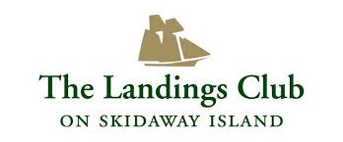  EARLY BIRD REGISTRATION  (Before 08/30/19)  $500 Team of 4  After 08/30/19 Registration Fee  $600 Team of 4  Reserve your spot today  Contact Leslie Eatherly at 912-236-4473 leatherly@savannahcblv.org | Includes:  - Beautiful 18 Hole Course  - Cart  - Pre-Play Lunch  - Complimentary Drinks on Course  - Awards  To register…Complete the information below and return with your registration fee to:  Leslie Eatherly, JIT Golf  SCBLV  1141 Cornell Avenue  Savannah, GA 31406  **If you plan to bring your own golf cart, mark here  CONTACT INFO  NAME: ______________________  COMPANY: ___________________  ADDRESS: ___________________  ___________________________  ___________________________  PHONE: _____________________  EMAIL: _____________________  TEAM  PLAYER #1 ___________________  PLAYER #2___________________  PLAYER #3___________________  PLAYER #4___________________  CREDIT CARD INFO  VISA MC AMEX  CARD # _____________________  EXP. DATE __________________  CVV CODE __________________  BILLING ZIP CODE ____________  SIGNATURE:  ___________________________
Thank you to These  2018 Sponsors….  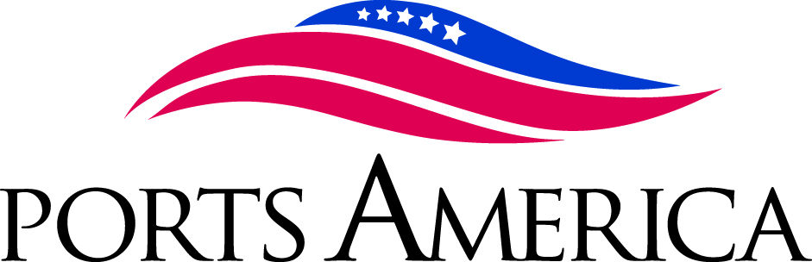  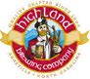  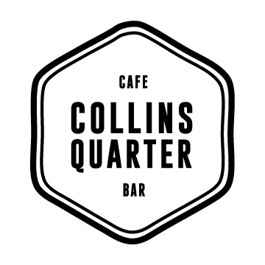  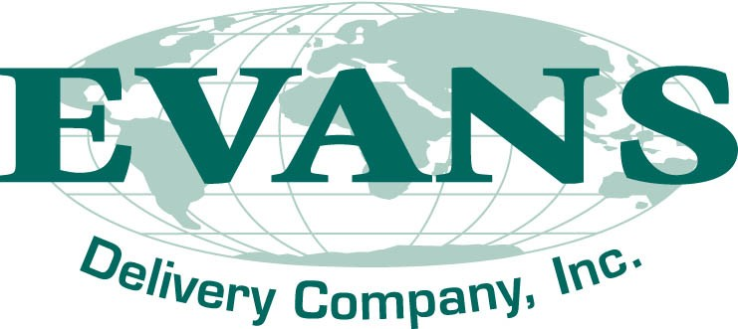  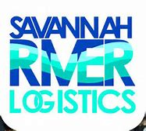  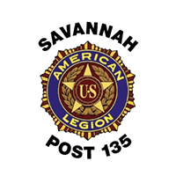  Agent Erica Herndon  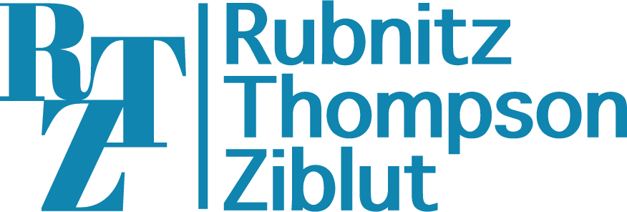  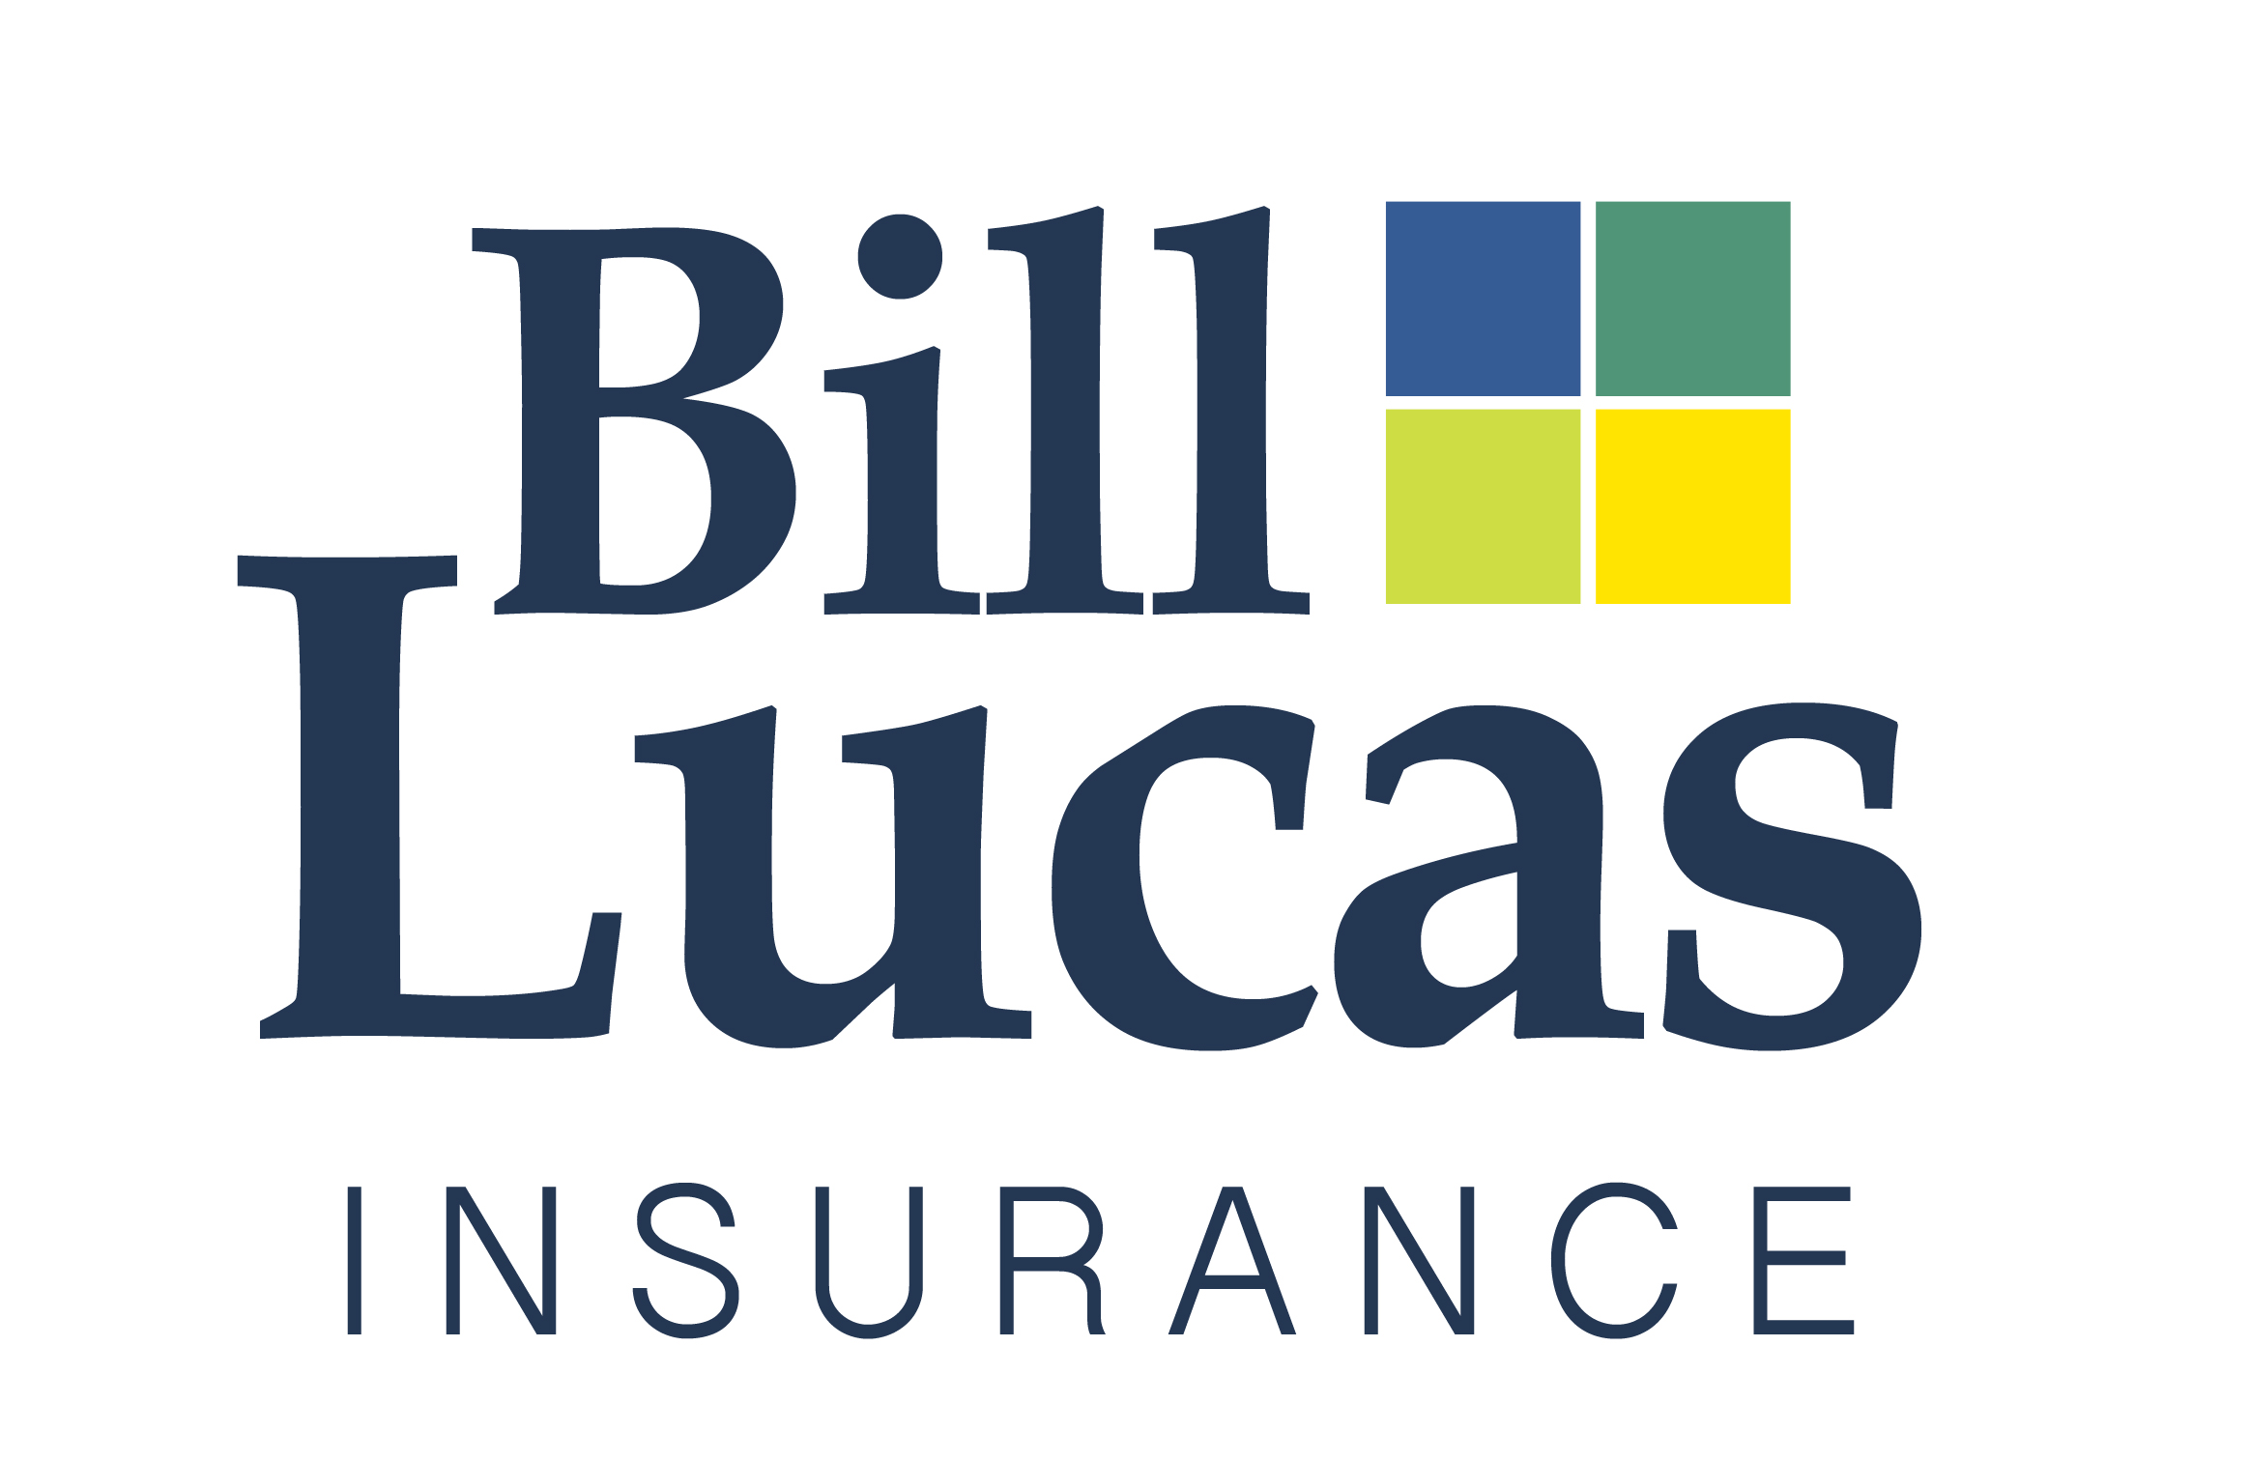  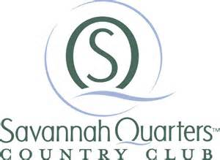  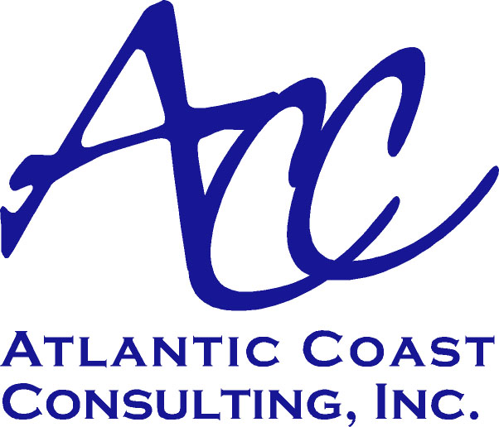  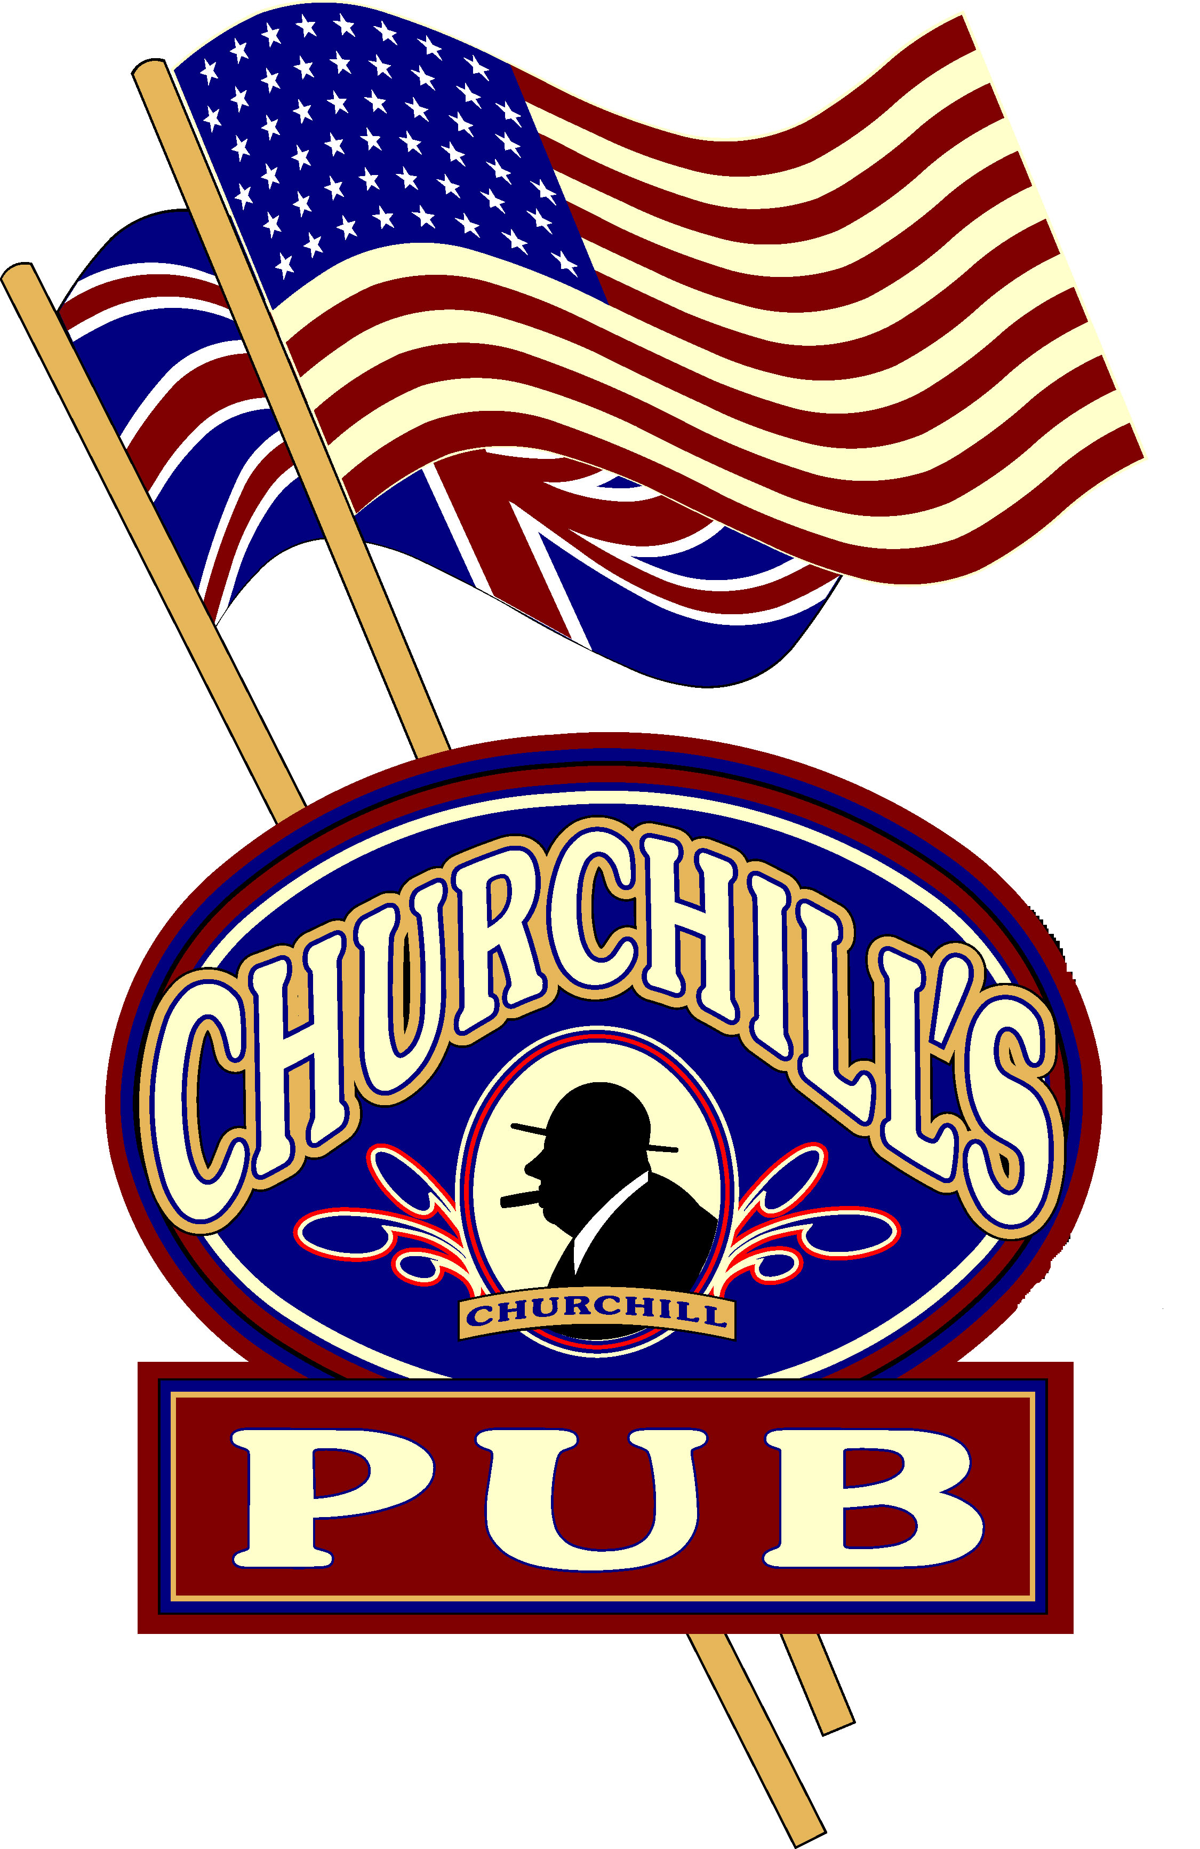  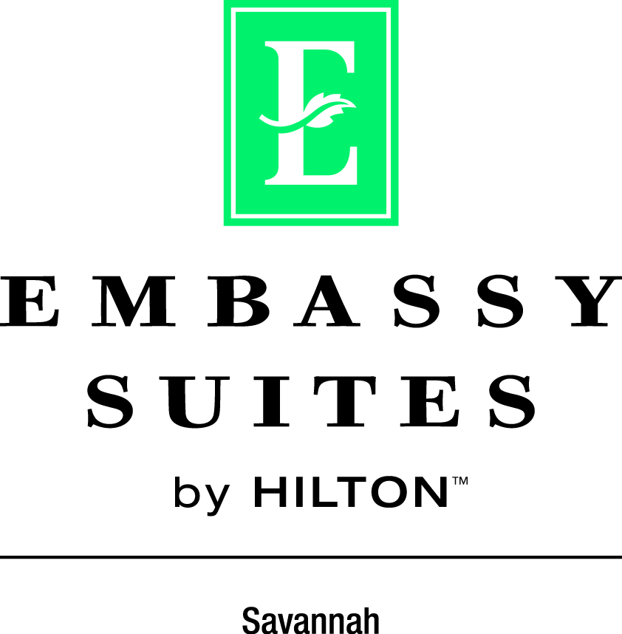  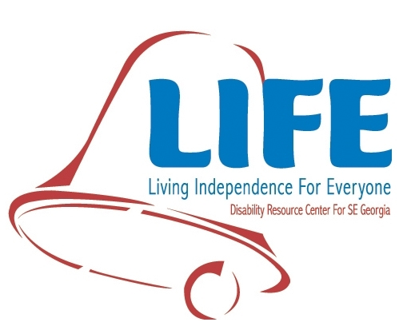  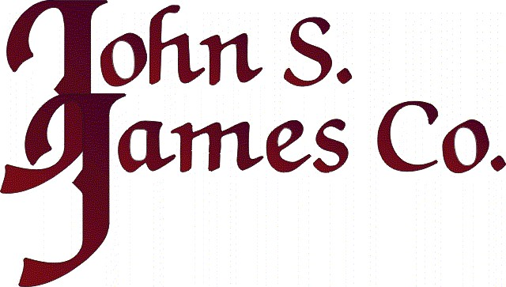  Sponsorship Level: ___ $3,500 ___ $2,500 ___ $2,000 ___ $1,500 ___ $100  Company Name: ________________________________Contact Name: ____________________  Address: _____________________________________ Phone: _____________________  Payment: Check? SCBLV, 1141 Cornell Ave., Savannah, GA 31406  Credit Card? Contact Leslie Eatherly at 912-236-4473 Extension 108 | Sponsorships  Available  $3,500 Course  - Two Complimentary Teams  - Display Space at Event  - Prominent Tournament Signage  - Announcement Recognition  - Branding on Carts  - Branding at 2 Holes on Course  - Recognition on SCBLV website  - Recognition in all PR Materials  $2,500 Prize  - One Complimentary Team  - Participation in Awards  - Prominent Tournament Signage  - Announcement Recognition  - Branding on 3 Carts  - Branding at 2 Holes on Course  - Recognition on SCBLV website  - Recognition in all PR Materials  $2,000 Food/Beverage  - One Complimentary Team  - Branding on pre-play “sack lunches”  - Announcement Recognition  - Signage in Awards Area during after play meal  - Branding at 1 Hole on Course  - Recognition on SCBLV website  - Recognition in all PR Materials  $1,500 Cart  - Announcement Recognition  - Branding on 64+ Carts  - Branding at 1 Hole on Course  - Recognition on SCBLV website  - Recognition in all PR Materials  $100 Hole  - Announcement Recognition  - Branding on Your Choice of Hole(s) on Course  - Recognition on SCBLV website

